Exercises – Introduction to DAX

# Exercise 6

Create the following custom visualization. You need a calculated column to scale the rating to a number from 1 to 5.



# Exercise 7

Use CALCULATE to create a measure that shows the number of distinct movies belonging to the Action genre.

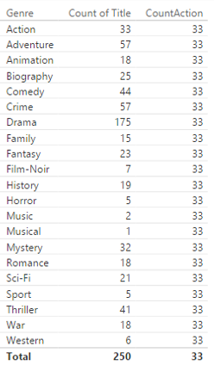

Expand the measure to show the number of movies of all genres.

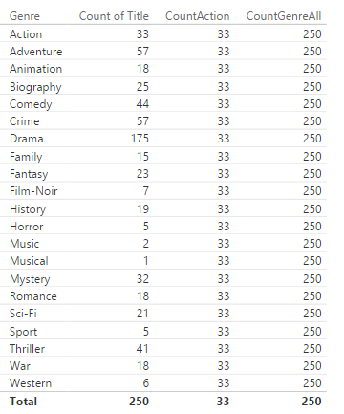

Now create a measure that calculates the % of total for the genre.

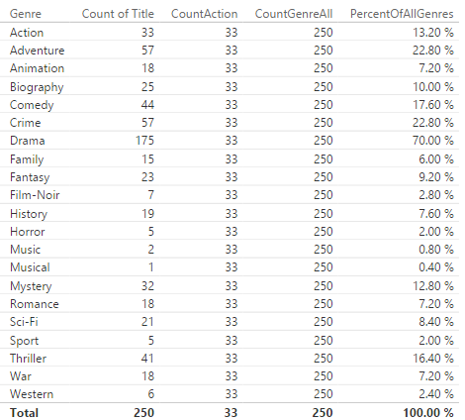

# Exercise 8

Create a calculated column that shows the number of distinct movies a director has directed. Who are the most popular directors?